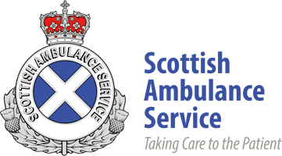


Eligible for Spring Vaccinations?
Drop in to the Mobile Vaccination Unit
at a location near you!

Thursday 24th April 2025 at 10.00am – 4.00pm
Clydebank Shopping Centre, 1 Argyle Rd, G81 1QA

Wednesday 18th June 2025 at 10.00am – 4.00pm
Clydebank Shopping Centre, 1 Argyle Rd, G81 1QA

No appointment necessary

Who can attend the drop in?

For Spring Programme 2025 eligible cohort for a COVID-19 vaccine will be offered to the following groups:

- Those aged 75 years and over (by 30th June 2025)

- People aged 6 months and over by 31 March 2025 (born on or before 30 September 2024) with a weakened immune system
We will be operating on a first come first served basis and there will be a set capacity each day.
For more information on Covid-19, please visit NHS inform Scottish health information you can trust | NHS inform

